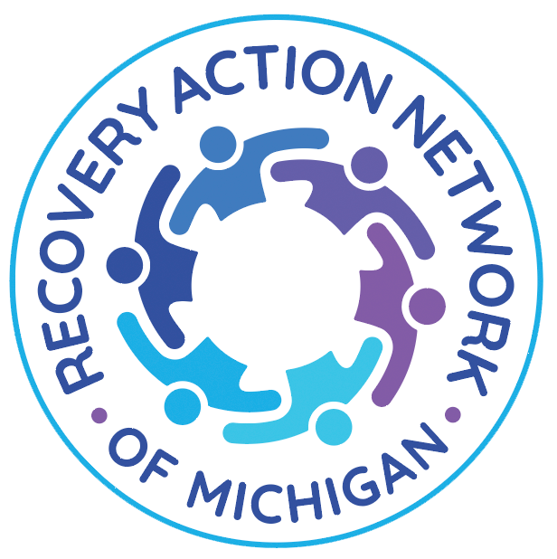

RECOVERY ACTION NETWORK OF MICHIGAN (RANMI)
Annual Report
Fiscal Year: October 1, 2024 – September 30, 2025

Table of Contents
Letter From the Executive Director…………………………………………...pg. 3
Mission, Vision, & Values……………………………….……………....……pg. 5
Our Story: Foundation & History……………………………………………..pg. 6
Key Metrics (February–September 2025)…………………………………….pg. 7
Programs & Services…………………………….…………….………….......pg. 8
Community Partnerships..................................................................................pg. 10
Stories of Impact...............................................................................................pg. 11
Financial Overview...........................................................................................pg. 12
Looking Ahead: 2026 Priorities........................................................................pg. 12
Leadership & Staff............................................................................................pg. 13

Call to Action: Be Part of the Recovery Movement………………………….pg. 14

LETTER FROM THE EXECUTIVE DIRECTOR
To our community, partners, supporters, and friends,
When I look back on this past year, I am overwhelmed with gratitude for how far we have come as a community and as an organization. RANMI began as a vision rooted in lived experience — the belief that recovery should be accessible, celebrated, and grounded in community connection. We launched in August 2023, and by October our board had formed, and I stepped into the role of Executive Director. Those early months were spent laying the foundation: developing partnerships, hosting virtual support groups, listening to the people we hoped to serve, and showing up wherever recovery support was needed.
Before we had funding or a physical space, we did what we could with what we had. We built relationships, hosted pop-up sober social outings, and offered community wherever we could find it. Our first major public event, the Annual Bowling Bash (June 2024), showed us just how much this region needed a dedicated Recovery Community Organization — a place where people could find hope, connection, and belonging.
Everything changed in February 2025 when we received our first major grant through the Michigan Department and Health and Human Services (MDHHS). Although we were already offering peer support and recovery services out of our small one-person office in Canton, this funding allowed us to expand our Recovery Support Services, secure a dedicated space in Wayne, and bring on staff to help support programming. In March, we moved into our Recovery Community Center in downtown Wayne, and on June 5, 2025, we celebrated our official grand opening. Today, our center has become a vibrant hub of peer support, harm reduction, education, and community engagement — and we are just getting started.
I also want to recognize Growth Works for their role in helping RANMI come to life. In our earliest days, before we had a center or a team, they believed in the value of peer-led recovery and the importance of creating a Recovery Community Organization for Western Wayne County. Their support and encouragement helped us build the foundation we needed to grow into the organization we are today. While RANMI operates independently with our own board, staff, and identity, we remain grateful for Growth Works’ partnership and their belief in our mission from the very beginning.
This past year, RANMI reached more people than ever before. Between February and September 2025, we supported 25 individuals through peer recovery coaching, engaged 953 participants in our multiple-pathway recovery groups, distributed 442 naloxone kits, provided 14 care coordination services, and attended 42 community events, including

resource fairs, educational workshops, and partner-hosted gatherings where we offered support and shared recovery resources. We launched new peer-led groups such as Eating
Disorders Anonymous, Marijuana Anonymous, LGBTQ+ AA (including the Pride in Sobriety meeting we originally established at the PC Alano Club), the Witch’s Recovery Circle, The Adventure of Recovery Club, and expanded our wellness pathways through the RANMI Run & Walk Collective.
We also showed up — everywhere we were needed. We offered overdose prevention trainings, co-hosted community events, supported students through the Alternative to Suspension program, partnered with the Well Wayne Initiative for harm reduction, and maintained a steady presence at local meetings, coalitions, and events. And we celebrated recovery loudly — through our recovery-centered events like the Recovery Rocks Battle of the Bands and our Global Peer Support Day Celebration, along with countless moments of community connection.
Looking ahead, RANMI is committed to continuing this momentum. We will keep strengthening our programming, expanding our harm reduction efforts, deepening partnerships, and creating new opportunities for people to find recovery in ways that feel authentic and possible for them. We will keep listening, learning, and leaning into the needs of Western Wayne County — and we will continue building a community where recovery is accessible and supported for all.
Thank you — to our board, our staff, our volunteers, our partners, and every person who has walked through our doors or supported this mission in any way. You are part of this movement, and your presence has helped shape who we are becoming.
With gratitude and hope,
Allison Herrst, LLMSW, CPRC, CPRM
Executive Director
Recovery Action Network of Michigan (RANMI)
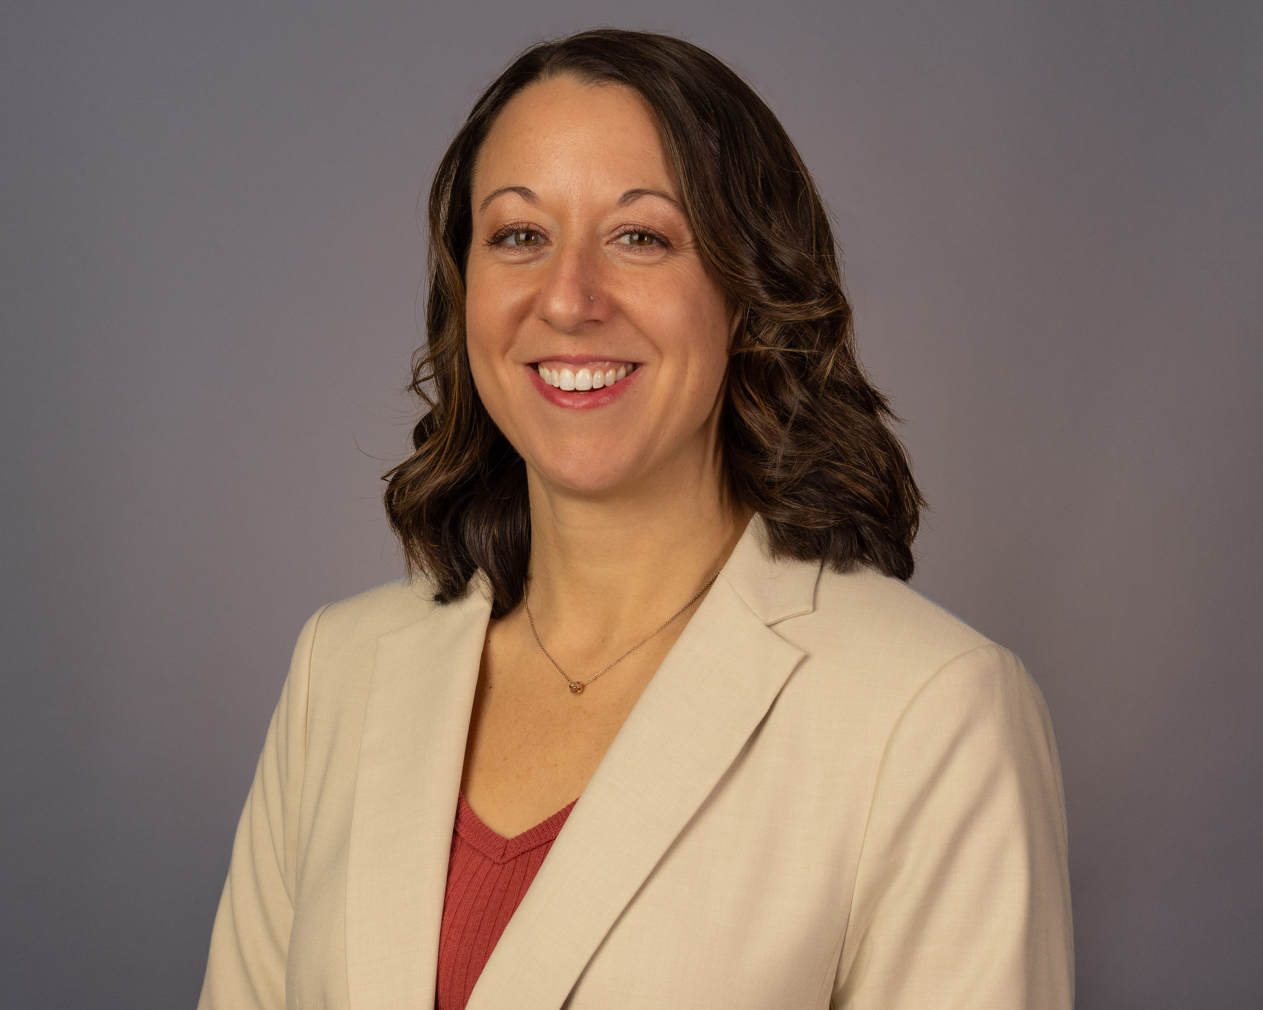

MISSION, VISION, & VALUES

Mission
Recovery Action Network of Michigan (RANMI) empowers individuals and families affected by addiction by providing a safe and supportive community where they can find hope, inspiration, resources, and achieve long-term recovery.

Vision
RANMI is committed to promoting a community that embraces and supports recovery for a diverse group of people. Built through humility, inclusiveness, and lived experience, we envision a safe, knowledgeable, and equitable community in which individuals actively in recovery, or those seeking it, can thrive.

Values
Person-Centered Support
Hope & Healing
Harm Reduction
Community Empowerment
Inclusivity & Equity
Multiple Pathways to Recovery

OUR STORY: FOUNDATION & HISTORY
RANMI launched in August 2023 with the belief that recovery should be accessible, community-centered, and grounded in lived experience. After the board formed in October 2023, RANMI began building the foundation of a Recovery Community Organization — developing partnerships, offering virtual support, hosting listening sessions, and facilitating sober social activities.
Our first large-scale community event, the Annual Bowling Bash in June 2024, highlighted the strong need for a peer-led recovery community in Western Wayne County.
In February 2025, RANMI received its first major grant through the Michigan Department of Health and Human Services (MDHHS), allowing us to expand services and move into our dedicated Recovery Community Center in Wayne. We celebrated our official ribbon cutting on June 5, 2025.

KEY METRICS (FEBRUARY–SEPTEMBER 2025)

- Peer Recovery Coaching
• 25 individuals supported

- Recovery Support Groups
• 953 total attendees
• 68+ meetings
• New and expanded groups
  - Eating Disorders Anonymous
  - Marijuana Anonymous
  - LGBTQ+ AA (two meetings, including Pride in Sobriety)
  - The Witch’s Recovery Circle
  - The Adventure of Recovery Club
  - RANMI Run & Walk Collective

- Harm Reduction
• 442 naloxone kits distributed
• 24/7 Narcan porch box
• Testing strips via Well Wayne
• Overdose prevention trainings

- Care Coordination
• 14 linkages to treatment, housing, and resources

- Community Engagement
• 42 events attended

PROGRAMS & SERVICES

Peer Recovery Coaching

Strength-based, person-centered support including recovery planning, harm reduction, coping strategies, and linkage to services.

Multiple Pathways Recovery Groups
RANMI embraces all pathways to recovery. Peer-led groups include:
- Eating Disorders Anonymous
- Marijuana Anonymous
- LGBTQ+ AA (two meetings, including Pride in Sobriety at the PC Alano Club and a second meeting at RANMI)
- The Witch’s Recovery Circle
- The Adventure of Recovery Club (Recovery-focused gaming group)
- RANMI Run & Walk Collective

Medication-Assisted Recovery Support
RANMI is committed to supporting individuals who use medication as a pathway to recovery. For over a year, we hosted a Medication-Assisted Recovery Anonymous (MARA) meeting to offer space and peer support for individuals using medication in their recovery process. Although the meeting concluded due to low participation, RANMI continues to prioritize medication-assisted pathways and is working with local MAT providers to offer community-based peer support, harm reduction education, and linkage to resources.

Harm Reduction Services
- Naloxone training and distribution
- Community Narcan porch box (via Well Wayne Initiative)
- Fentanyl and xylazine test strips (via Well Wayne Initiative)
- Safety planning and overdose prevention education

Youth & Family Engagement
- Collaboration with local school districts
- Support for the Alternative to Suspension Program
- Prevention and education for parents and teens

Sober Social & Community-Building Activities
RANMI hosts a variety of sober and wellness-based events including:
- Sober bar nights
- Community picnics
- Mindfulness workshops
- Journaling workshops
- Hikes and dog walks
- Seasonal gatherings
- Other peer-led creative and wellness-focused activities

COMMUNITY PARTNERSHIPS
RANMI collaborates with a wide network of community organizations, including:
- Growth Works
- Hegira Health
- Face Addition Now (FAN)
- The Phoenix Detroit
- Passenger Recovery
- Western Wayne Family Health Centers
- Livonia Save Our Youth Coalition
- Trinity Health Livonia
- Sanford Behavioral Health
- HYPE Athletics
- Schoolcraft College
- Plymouth-Canton Community Schools
- Livonia Public Schools
- PC Alano Club
- Metro West Alano Club
- City of Wayne (Mayor, City Council, Police Department, Wayne Rotary)
- Wayne State University Center for Behavioral Health & Justice
- Well Wayne Initiative
- Local civic groups, businesses, coalitions, and treatment courts

Treatment & Behavioral Health Providers
RANMI supports individuals transitioning from treatment into the community by offering peer support, harm reduction, and linkage to multiple recovery pathways.

Justice & Treatment Court Support
RANMI provides community-based recovery support for justice-impacted individuals connected to local treatment courts throughout Western Wayne County.

STORIES OF IMPACT
A Teen Finds Support Through Harm Reduction
A parent brought their teenager to one of our community overdose prevention trainings. After the session, the teen confided that friends were experimenting with substances, and they didn’t know how to stay safe. Our peer team provided education, harm reduction tools, and youth-friendly resources. Months later, the parent shared that the training “changed how we talk about safety at home” and empowered the teen to encourage peers to seek help.
LGBTQ+ Recovery Support Creates Community
When RANMI launched an LGBTQ+ recovery meeting, one participant shared they had been searching for an affirming space for years. Through the group, they found supportive conversation, connection, and renewed confidence. Today, they volunteer at events and welcome new members — often saying the meeting “gave me a place where I finally feel seen.”
Connection Through Movement
Several individuals joined the RANMI Run & Walk Collective after discovering that movement helped them stay grounded in early recovery. Walking or running gave them a healthy outlet for stress and a sense of belonging. Today, some participate in local races, volunteer with the group, and describe it as “a meaningful part of staying connected in recovery.”

FINANCIAL OVERVIEW
Revenue
• Michigan Department of Health and Human Services (MDHHS) RSSC Grant: $150,000
• Ethel and James Flinn Foundation Grant: $5,000
• Donations: $2,207.69
• Fundraising Net (Bowling Bash): $656.99
Expenses
• Peer staff and programming
• Rent and utilities
• Harm reduction supplies
• Community engagement
• Administrative costs

LOOKING AHEAD: 2026 PRIORITIES
• Expand harm reduction efforts
• Strengthen multiple pathways programming
• Grow youth and family engagement
• Increase community visibility
• Expand volunteer and advisory board involvement
• Build long-term organizational sustainability

LEADERSHIP & STAFF
Board of Directors
• David Sculati — President
• Laurie Gustafson — Vice President
• Jason Schwartz — Treasurer
• Michele Baldori-Fuhst — Secretary
• Jessica Klotz — Board Member
• John Casteel — Board Member
Staff
• Allison Herrst — Executive Director
• Josh Puckett — Outreach Coordinator / Certified Peer Recovery Coach (CPRC)
• Andrea Amerson-Vinson — Certified Peer Recovery Coach (CPRC)
• Liza Esqueda — Administrative Assistant

Call to Action: Be Part of the Recovery Movement
The impact shared in this report reflects what is possible when community, compassion, and lived experience come together. Recovery Action Network of Michigan exists because people believed in the power of peer-led support—and chose to show up.
As the need for recovery support continues to grow, so does the importance of sustaining and expanding this work. Our Recovery Community Center has become a place where individuals and families find connection, safety, and hope through peer support, harm reduction, education, and community engagement.
You can help shape what comes next.
Support RANMI by donating or getting involved.
Financial contributions help ensure that recovery support, harm reduction resources, and community programming remain free and accessible to all. Volunteers strengthen our work by supporting events, outreach, and peer-led programming, and by bringing their skills, time, and lived experience into the heart of our community.
Recovery does not happen in isolation—it happens in relationship. Together, we can reduce stigma, prevent overdose, strengthen families, and make recovery visible and accessible throughout Western Wayne County.
Learn more, donate, or get involved:
🌐 ran-mi.org
📱 Follow us on Facebook, Instagram, and LinkedIn
Together, we are building a community where recovery is supported, celebrated, and sustained.
Scan to learn more, donate, or get involved.
